History & Concept of Cell Culture Development
Animal Cell Culture is the process of in vitro propagation of cells artificially under aseptic conditions. The cells are isolated, maintained and grown under controlled conditions, generally outside their natural environment in culture media containing a suitable mixture of nutrients (amino acids, carbohydrates, vitamins, minerals), growth factors, hormones and gases (CO₂, O₂) which helps to regulate the physico-chemical environment required for proper development of the cells.
- Primary Culture: It is prepared by the inoculation of cells that are directly isolated from the tissues of an organism into the culture medium containing all the essential nutrients required for its growth. These cells represent the properties of the tissues from which they are originated. Most of the primary cultures have a limited lifespan except the cells isolated from tumor cells. This is attributed to the fact that there is gradual shortening of cell’s telomeres, the repetitive DNA sequences and associated proteins that cap the ends of each chromosome. Thus, with the passage of time, cells stop dividing due to limited proliferating capacity and undergo senescence.
Primary culture is mainly divided into attachment culture and suspension culture. The cells that require a surface for attachment in order to proliferate are known as adherent or anchorage dependent cells and the process involving their isolation and maintenance is regarded as attachment culture. For example: the cells isolated from the tissues of kidney are immobile and embedded in connective tissue. On the other hand, the cells that do not require surface attachment for their survival and growth are anchorage independent cells (For eg. Lymphocytes).
- Secondary Culture: It is prepared by the subculturing of primary culture where the cells are transferred from one culture vessel to another rather than direct isolation from the tissues. It is mainly required for the maintenance of cultures that are made to proliferate to form a large number of secondary cultures.
- Cell Line: These are formed by the subculturing of the primary culture. The cell lines may be distinguished as the finite cell line and infinite or continuous cell line. The finite cell lines possess the properties of contact inhibition, density limitation and anchorage dependence where the cells die after several subcultures depicting limited number of possible subcultures. For example, normal mammalian cells stop dividing and represent a finite life span in culture. The infinite cells, elseways, have boundless number of possible subcultures that do not exhibit the properties of contact inhibition, anchorage dependence and density-dependant inhibition. The cells categorized in this group are mainly tumor cells or the normal transformed cells (treated with certain chemical carcinogens or viruses) that have potential to grow indefinitely even in presence of reduced growth factors and serum. Since the transformed cells are produced by treating normal cells with certain chemicals, these lines often observed as aneuploid that overproduce different proteins. Thus, all the immortal cancer cells are regarded as transformed cells but all the transformed cells are not considered to be cancerous.
- For example:
The first cell line- the mouse fibroblast L cell, was derived from cultured mouse subcutaneous connective tissue by exposing the cultured cells to a chemical carcinogen.
HeLa cella were derived from a 31 year old woman named Henrietta Lacks, who died of cervical cancer in 1951.
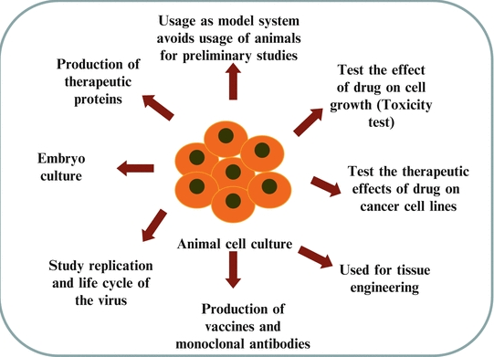

Historical Perspective
Scientists | Work done | Contribution
Sydney Ringer (19th Century) | Preparation of salt solutions comprising of chlorides of Na, K, Ca and Mg for maintaining the beating of an animal heart artificially | Encouraged the possibility of maintaining tissues under in vitro conditions
Wilhelm Roux (1885) | Maintained the cells isolated from medullary plate of an embryonic chicken in warm saline solution for several days | Established the principle of tissue culture
Ross Granville Harrison (1907) | He was the first to develop frog tissue culture technique. The fast tissue regeneration in frog and no requirement of incubation because of being cold blooded animal could have been the reason for its selection. | Established the methodology of tissue culture
J.F. Enders, T.H. Weller and F.C. Robbins | Standardized the method for the growth of virus in monkey kidney cell cultures | Cell culture research
Jonas Salk | Development of injectable polio vaccine | The first product prepared using cell culture technique

Among the various animal cell cultures (Chick embryo tissue developed in 1940’s, human tissues culture in 1950’s), mouse cell cultures are the most commonly used in the laboratory.

